**Introduction**

Plugging into the future an Exploration of Electricity Consumptions patterns

OVERVIEW

The overview of our project was done in the of tableau platform, first of all creating account in that platform and then fill our further details in it.

PURPOSE

Purpose of our project was the to save the electricity

PROBLEM DEFINITION AND DESIGN THINKING

EMPATHY MAP,

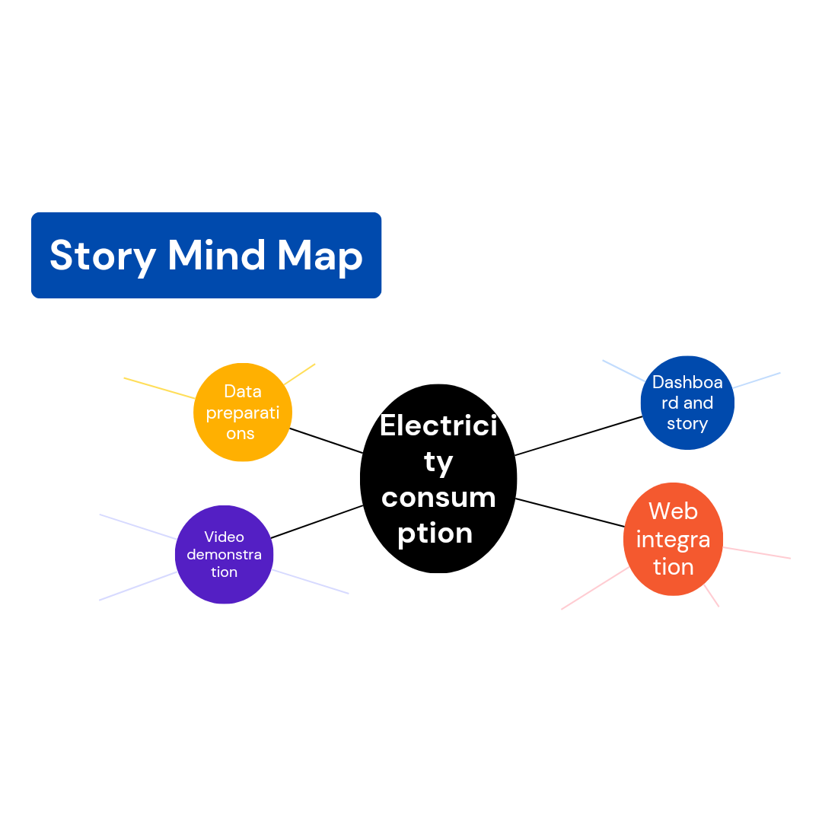

Brainstorming map

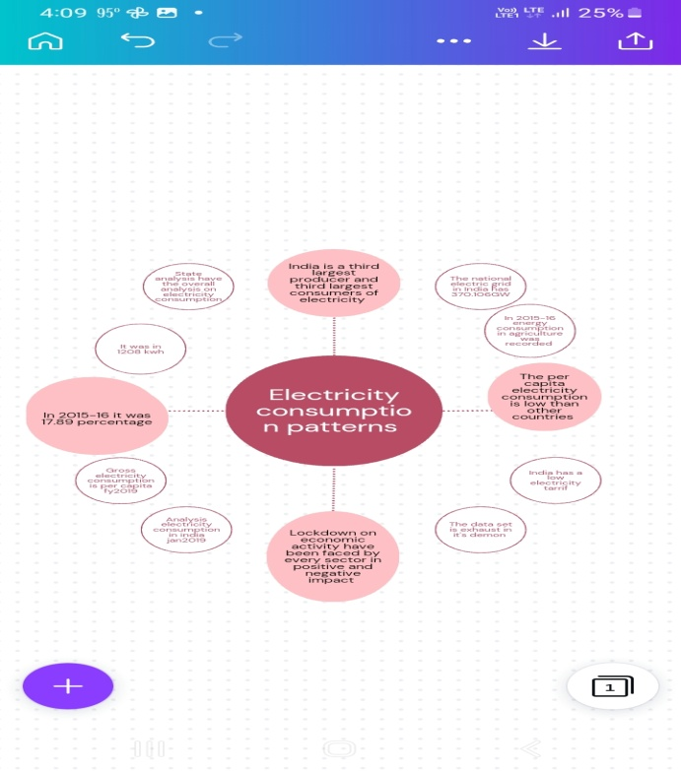

RESULT

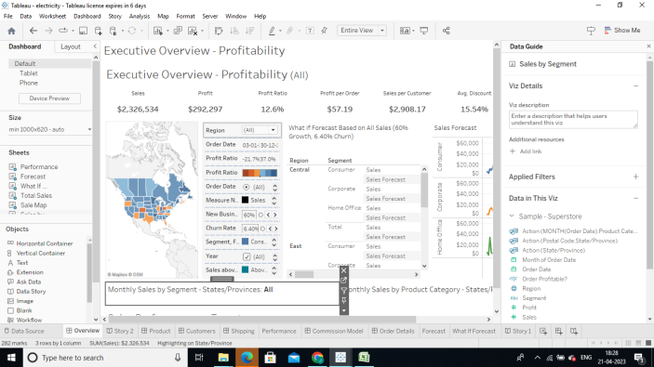

The final output of our project is above dashboard and story screenshot by graphical and map representations

ADVANTAGES AND DISADVANTAGES

Advantages of our projects to be having the great per capita percentages .electricity is one of the most important fundamental needs to be human alive.

Disadvantages of our projects to be lack of electricity savings in city culture

APPLICATIONS

Our project applications include in many power plant projects

CONCLUSION

Electricity is a gift from nature don’t to be use in unwanted ways use it carefully ,and follow the

Safety measures about electricity

THANK YOU